**Nested Loops**

A nested loop is a loop inside another loop. A clock is a good example of something that works like a nested loop. The second hand, minute hand, and hour hand all spin around the face of the clock. The hour hand, however, only makes 1 revolution for every 12 of the minute hand’s revolution. And it takes 60 revolutions of the second hand for the minute hand to make 1 revolution. This means that for every complete revolution of the hour hand, the second hand has revolved 720 times. Here is a loop that partially simulates a digital clock. It display the seconds from 0 to 59.

for seconds in range(60):  
 print(seconds)

We can add a minutes variable and nest the loop above inside another loop that cycles through 60 minutes:

for minutes in range(60):  
 for seconds in range(60):  
 print(minutes, ‘:’, seconds)

To make the simulated clock complete, another variable and loop can be added to count the hours:

for hours in range(24):

for minutes in range(60):

for seconds in range(60):

print(hours, ':', minutes, ':', seconds)

The clock output would be:

0:0:0  
 0:0:1  
 0:0:2

(The program will count through each second of 24 hours)

23:59:59

The innermost loop will iterate 60 times for each iteration of the middle loop. The middle loop will iterate 60 time for each iteration of the outermost loop. When the outermost loop has iterated 24 times, the middle loop will have iterated 1,440 times and the innermost loop will have iterated 86,400 times!

Below is the flow chart to the complete clock simulation program above.

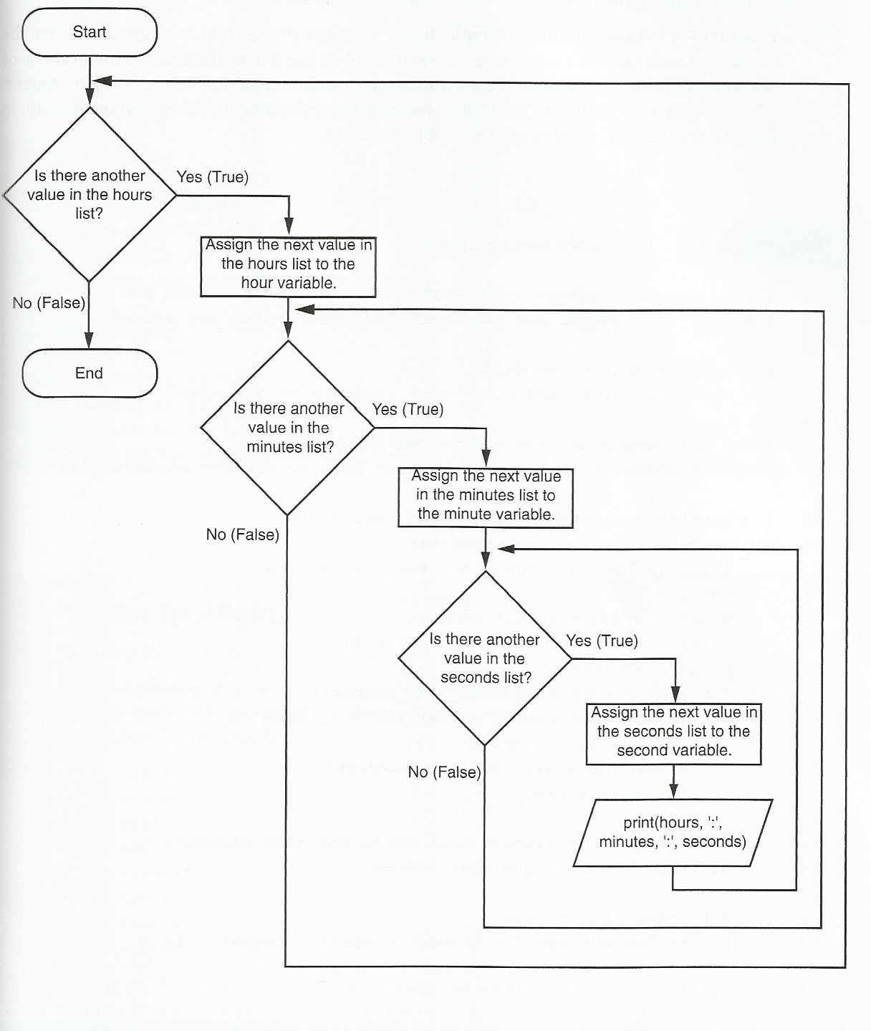

**Nested Loop – Test Scores**

Create a program a teacher could use to get the average of each student’s test scores. The statement in line 5 asks the user for the number of students, and the statement in line 8 asks the user for the number of test scores per student. The for loop that begins in line 11 iterates once for each student. The nested inner loop, in lines 17 through 21, iterates once for each test score.

# This program averages test scores. It asks the user for the number of students and number of scores per student

# Get number of students

num_students = int(input('How many students do you have? '))

# Get the number of test scores per student

num_test_scores = int(input('How many test scores per student? '))

# Determine each student’s average test score

for student in range(num_students):

# Initialize an accumulator for test scores

total = 0.0

# Get a student’s test scores

print('Student number', student + 1)

print('---------------------------------------------')

for test_num in range(num_test_scores):

print('Test number', test_num + 1, end=' ')

score = float(input(': '))

#add the score to accumulator

total += score

# Calculate the average test scorefor this student

average = total / num_test_scores

# Display the average

print('The average for student number', student + 1, 'is: ', average)

print()

**Nested Loop - Rainfall**

Write a program that uses a loop to collect data and calculate the average rainfall over a period of years. The program should first ask for the number of years. The outer loop will iterate once for each year. The inner loop will iterate twelve times, once for each month. Each iteration of the inner loop will ask the user for inches of rainfall for that month. After all iterations, the program should display the number of months, the total inches of rainfall, and the average rainfall per month for the entire period.

# Declare variables to hold the total rainfall,

# monthly rainfall, average rainfall, the number

# of years, and the total number of months.

totalRainfall = 0.0

monthRainfall = 0.0

averageRainfall = 0.0

years = 0

totalMonths = 0

# Get number of years

years = int(input('Enter the number of years: '))

# Get rainfall by month

for year in range(years):

print ('For year ', year + 1, ':')

for month in range(12):

monthRainfall = float(input( \

'Enter the rainfall amount for the month: '))

# Add to total number of months

totalMonths += 1

# Add to total rainfall amount

totalRainfall += monthRainfall

# Calculate the average rainfallji

averageRainfall = totalRainfall / totalMonths

print('For ', totalMonths, 'months')

print('Total rainfall: ', format(totalRainfall, '.2f'),'inches')

print('Average monthly rainfall: ',format(averageRainfall, '.2f'),'inches')